***Assignment # 3***

|  |  |
| --- | --- |
| **Name** | Muhammad Asad |
| **Roll #** | 2019-EE-383 |
| **Section** | A-G1 |



***Programming Fundamentals***

**Lab # 3**

* **Objectives:**

* The First Objective of this lab is to develop the concept of scanner class to take the input from the user.
* The second objective of this Lab is to create a how know about solving simple Mathematics and algebra
* **Task 1:**

Write a program which converts the Fahrenheit to the degree Celsius where

C=5/9(F-32).

* **Code:**

import java.util.*;

**//This statement imports the util package**

public class FahrenheitToCelcius {

public static void main(String[] args) {

Scanner input = new Scanner (System.in);

**//System.in is a standard input stream**

System.out.print("Enter The Temperature in Fahrenheit");

float F= input.nextInt();

**//We declared the F as float to be declared**

F=((F-32)*5)/9;

System.out.println("Temperature in Calcius is = "+F);

}

}

* **Output:**

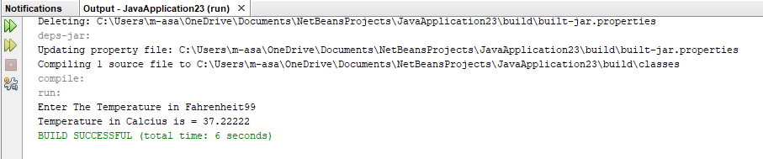

* **Task # 2:**

Write a code which takes the input from user and prints the output on the output screen.

* **Code:**

import java.util.Scanner;

public class NewClass {

public static void main(String[]args){

int num;

System.out.println("Write a number to be squared:");

Scanner scan=new Scanner(System.in);

num=scan.nextInt();

num=num*num;

System.out.println("Squre of a number is :"+ num);

}

}

* **Output:**

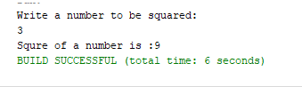

* **Task 03:**

Write a program which find slope from linear equation of line.

* **Code:**

import java.util.Scanner;

public class NewClass {

public static void main(String[]args){

Scanner scan=new Scanner(System.in);

System.out.println("1st point of X coordinate");

double X1=scan.nextInt();

System.out.println("2nd point of X coordinate");

double X2=scan.nextInt();

System.out.println("1st point of Y coordinate");

double Y1=scan.nextInt();

System.out.println("2nd point of Y coordinate");

double Y2=scan.nextInt();

double a=Y2-Y1;

double b=X2-X1;

double slope=a/b;

System.out.println("The slope of Equation is :"+ slope);

}

}

* **Output:**

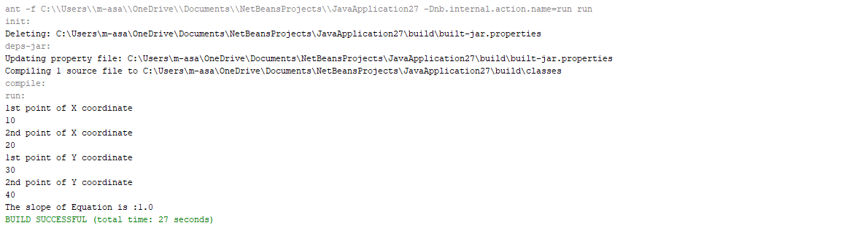

* **Task 04:**

Ask a user to enter two numbers find out whether bigger number is divisible by smaller number.

* **Code:**

import java.util.Scanner;

public class NewClass {

public static void main(String[]args){

Scanner scan=new Scanner(System.in);

System.out.println("enter a large number");

int large=scan.nextInt();

System.out.println("enter a small number");

int small=scan.nextInt();

if( large % small==0)

System.out.println("large number is divisible by small number");

else

System.out.println("large number is NOT divisible by small number");

}

}

* **Output:**

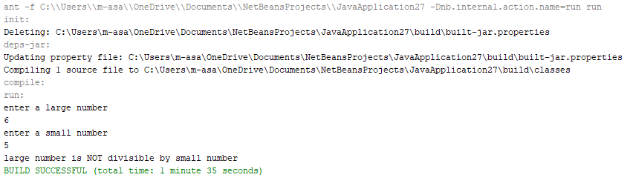

* **Conclusion:**

This lab helped me upgrading my mental abilities about Java.

* We can take inputs from user by using simple scanner class and can display output on screen.
* We can create simple logics about problems in mind and can easily solve by creating a code based on that logic.